STEP TO SETUP LYNC DIAL IN NUMBER
NOTE: This process involve 2 phase – phase 1 (step 1-3 user need to do after receiving the email) phase 2(step 4-7 which user need to do after 1.5 hr. once step 3 is completed)

Phase-1
Step-1: Login to Corporate Directory http://corporatedirectory.capgemini.com and click on “My Details”
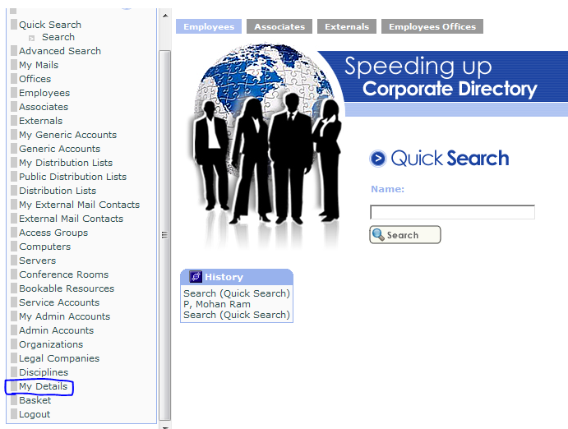

Step-2: Then Click on “Edit Skype”
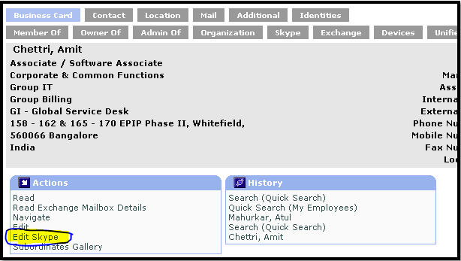

Step-3: In Dial-in Phone Number - give your Cellphone number and in Ext Dial-in Phone Number - give your EXT Number (if you don’t have an EXT, then give the last 5 or 8 digits of your Cellphone) and click “Save”
NOTE: do not give anything in RESET PIN
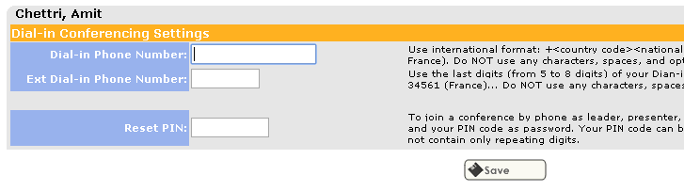

Phase-2
Step-4: After this is done, wait for 1.5hr. and then go to https://lync.capgemini.com/dialin and click on “Sign-in”
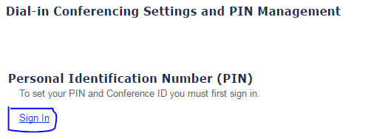

Step-5: Click on “Sign in with a different account” and login as CORP\Login ID and Corp Password

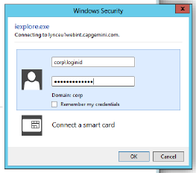

Step-6: Once logged in, click on Reset PIN, give the PIN (5 Digits) and click Save
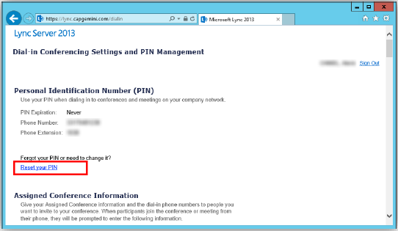

Step-7. Set up your PIN change, provide a new PIN code and confirm it
